4 August, 2022
ISUZU TECHS SET TO TAKE ON THE WORLD
Two talented Isuzu Truck service technicians from regional Australia will test their skills against competitors from around the world at the prestigious Isuzu World Technical Competition, the I-1Grand Prix (I1GP) later this year.
Veteran technician Brad Hickey from Peel Valley Isuzu in Tamworth and newcomer Louis Holt from Bendigo Isuzu will represent Australia at Isuzu’s international competition after taking out the top honours at the Isuzu National Technical Skills Competition in Melbourne this week.
It wasn’t Brad’s first rodeo. He made it to the National Technical Skills Competition several times over the last few years. This year he stormed home to win, meaning he will pit his skills against technicians from more than 40 countries around the world at the I-1 Grand Prix on November 4.
“Making the national team has been something I’ve been working towards for so long,” Brad said. “When they called out my name, I didn’t really believe it and started tearing up.”
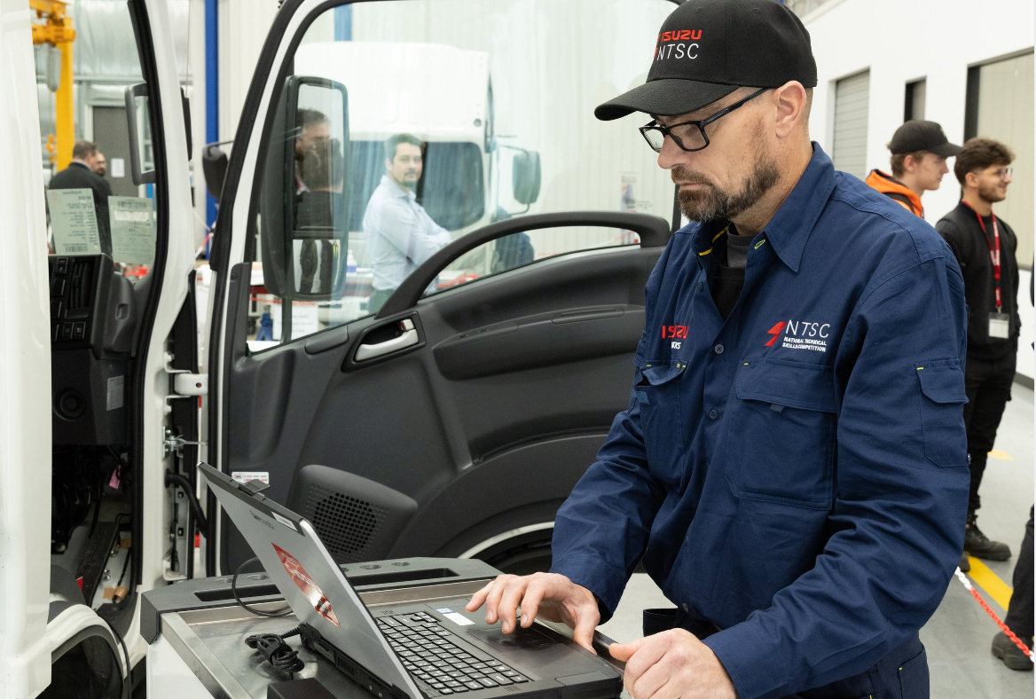
https://isuzu.imagerelay.com/share/ee7954256ce3468288d4014265b67c0d
Meanwhile, Louis put in a stellar performance to place second in his first-ever attempt at the competition, which this year took the form of a one-hour written exam and a one-hour on-vehicle exercise.
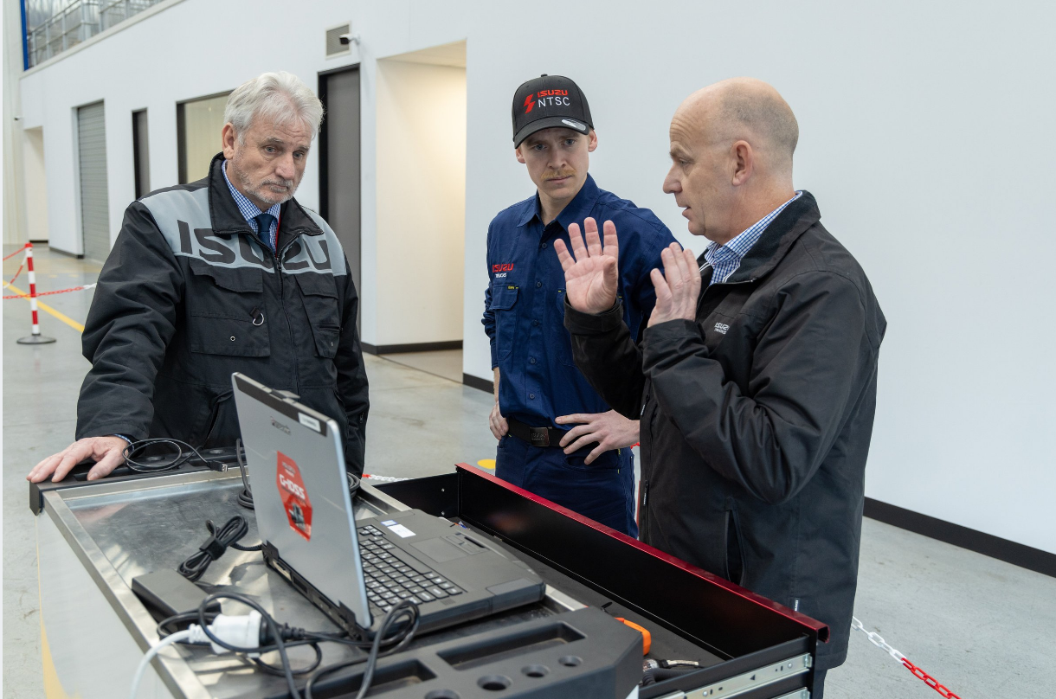
https://isuzu.imagerelay.com/share/41f61988b7b44b3fa731a2860b7d298f
“I just can’t believe I did it!” Louis said.
“I’m super excited for the overall experience and hopefully I represent my country well.”
Brad and Louis were among a pool of 63 Isuzu apprentices and technicians who took part in an online qualifier event earlier in July. The top eight technicians and the top eight apprentices in that event squared off at this week’s national competition at Isuzu Australia Limited’s (IAL’s) Melbourne headquarters.
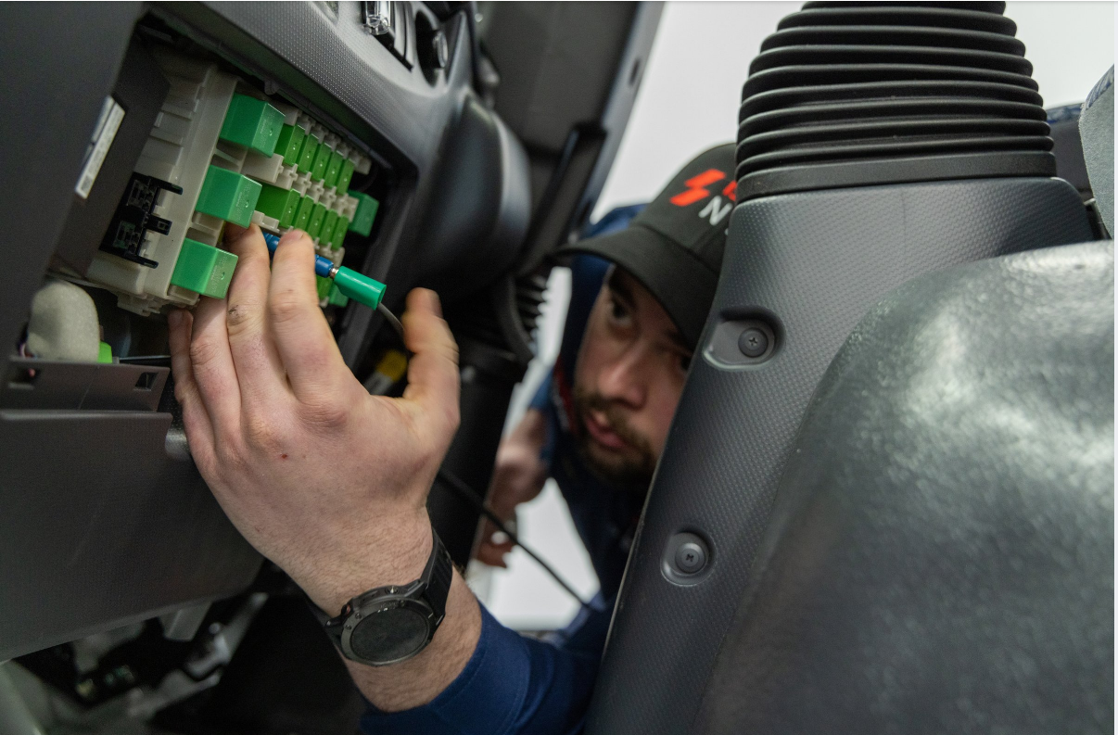
https://isuzu.imagerelay.com/share/73d6c591afdc48159fe89082279c9ac0
Brad said his strategy for the international competition was to stick to their processes and get the little things right.
Meanwhile Louis attributed his win to the simple fact that he loves his job.
“I find being a mechanic a very satisfying job, very rewarding,” he said. “The best thing is when a truck comes in and it’s not running, and you go straight up to it and within 10 minutes you’ve found a solution. It’s rewarding, very rewarding, and that’s why I’m in the job.”
With a focus on the skills shortage and building career pathways, IAL this year introduced an Apprentice category and a State of Origin into the National Skills competition as a way of progressing their technicians and also adding some home state pride.
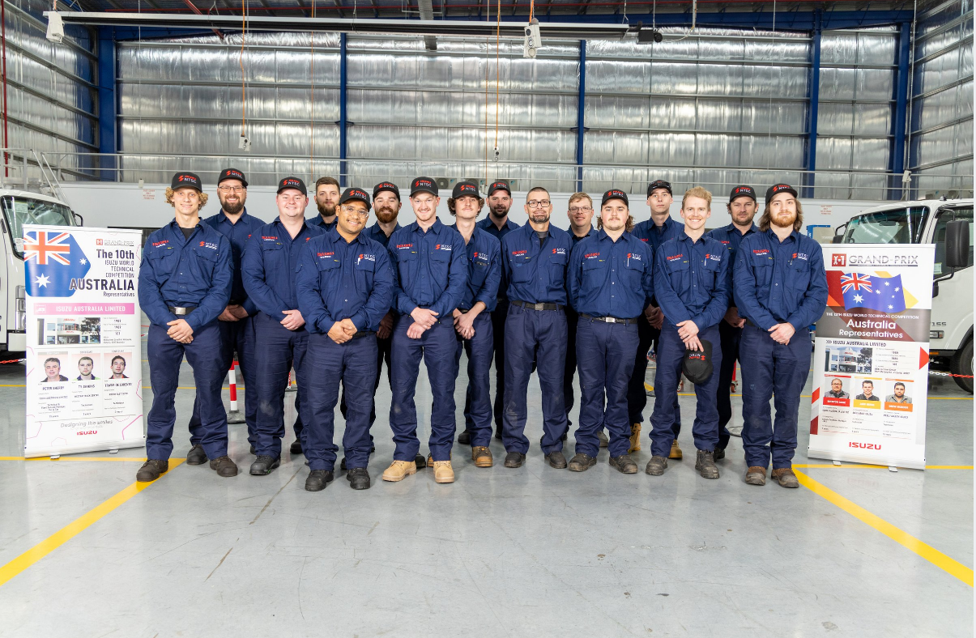
https://isuzu.imagerelay.com/share/0a3439384cb44fe494888bdf6bd04b3c
The winners from the Apprentice Category were Jaiden McManus (North East Isuzu Burton) and the runner up was Sam Allan (Ballarat Isuzu), and NSW took out honours for the teams-based category which was made up of Brad Hickey (Peel Valley), Kaylem Brown (Canberra Isuzu), Tom O’Conner (Gilbert and Roach Isuzu Hexham) and Pradeep Siddiki (Suttons Motors Arncliffe).
There were some fantastic prizes up for grabs also with all competitors making it through to the National skills competition having their choice to receive either of the following:
- Milwaukee 18v Fuel™ 1/2" High Torque Impact Wrench Kit
- Milwaukee 18v Fuel™ One-Key™ 3/4" High Torque Impact Wrench Kit
In addition, the top two placing technicians/apprentices will receive Snap-On tools of their choice to the value of:
- Technician category - $5,000
- Apprentice category - $2,500
IAL National Training Manager David Smith said the Australian team had a very real chance at international success at the I-1 Grand Prix event.
“Our technicians at Isuzu Australia have some fantastic training opportunities and we’ve shown before we can take on the best around the world and win,” Mr Smith said.
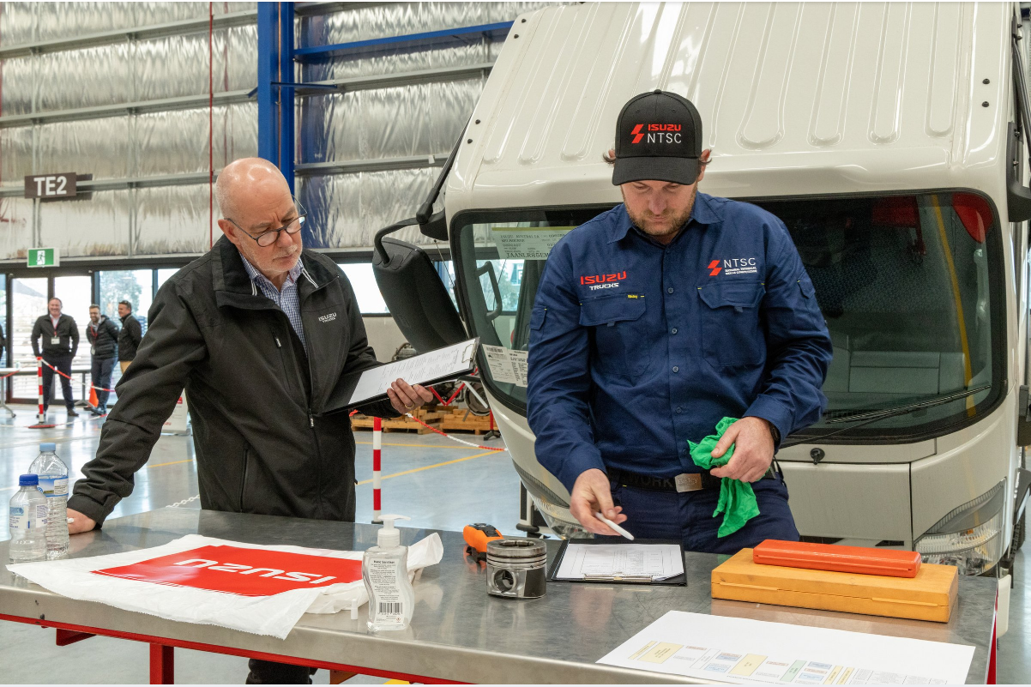
https://isuzu.imagerelay.com/share/c1d16d4560c84e3cbcbf677abe478ccb
IAL’s team won the international competition in 2011, and made podium finishes in six more of international events.
Pre-covid, the annual I-1 GP was held in Japan since 2006 but this year the event is once again a virtual competition.
Mr Smith said providing training and support was particularly crucial at the moment, with Australia and the world in the grip of a skills shortage.
“All 16 competitors who made it to the national competition performed really well, but Brad and Louis and apprentices Jaiden and Sam did some stand-out work to win the competition. I wish Brad and Louis the best of luck in the international event in November.”
ends

For further information, please contact: For Isuzu Trucks releases and photos:
Sam Gangemi Arkajon Communications
Isuzu Australia Limited Phone: 03 9867 5611
Phone: 03 9644 6666 Email: isuzu@arkajon.com.au

